**Bus Analysis User Manual**

# **Introduction**

Bus Analysis program is used to evaluate and optimize the performance of bus lines. The evaluation is based on equality and DEA. The optimization is based on linear programming by using glpk package.

The source files can be found at:

<https://github.com/rwei5/Transit-Performance>

Any input sample file can be found in

<https://github.com/rwei5/Transit-Performance/tree/master/input>

# **Prerequisite**

1. A windows PC
2. **launchBusAnalysis**.exe
3. **glpk** package which contains glpsol.exe.

# **How to Use the Software**

# **Launch Main Window**

The program can be simply launch by double clicking launchBusAnalysis.exe. After that, you can see a window below.

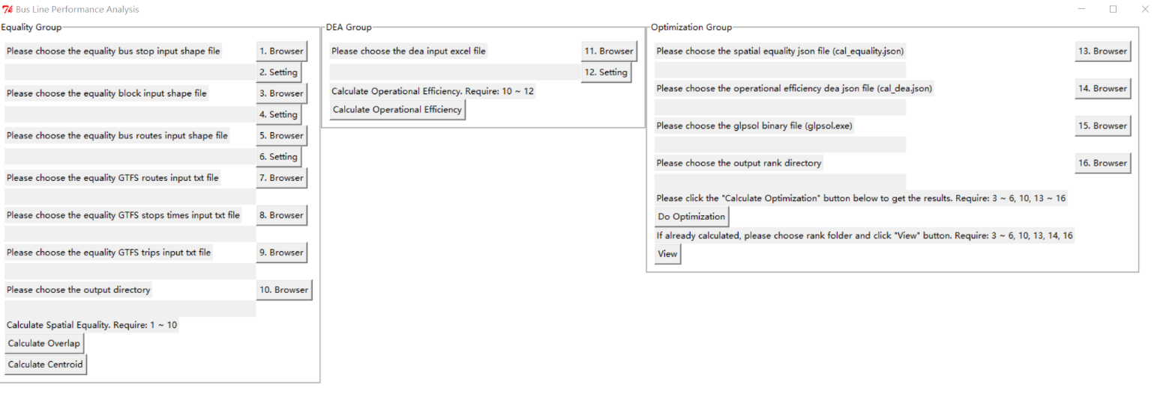

Figure 1. Main window

# **Calculate Equality**

There are two methods to calculate the equality, Overlap and Centroid. Both of the two methods need to fill item 1 to 10.

# **Choose Bus Stop Input Shape File**

First, click the “1. Browser” button and choose the bus stop input shape file, e.g. BusStops_UTA.shp.

Then click the “2. Setting” button to choose the field in the shape file which can represent the stop id.

Like the figure below.

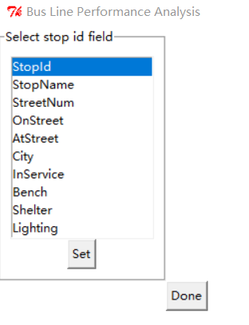

Figure 2. Select stop id

Finally, click “Set” -> “Done”.

# **Choose Block Input Shape File**

First, click the “3. Browser” button and choose the block input shape file, e.g. UT_blck_grp_2010.shp.

Then click the “4. Setting” button to choose the field in the shape file which can represent the population id.

Like the figure below. The example chooses the “Age” as the population field, but others such as “Race”, “Poverty” are also acceptable.

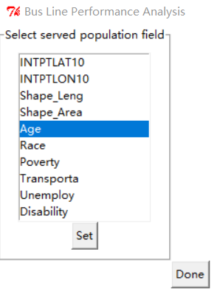

Figure 3. Select population id

Finally, click “Set” -> “Done”.

# **Choose Bus Routes Input Shape File**

First, click the “5. Browser” button and choose the bus routes input shape file, e.g. BusRoutes_UTA.shp.

Then click the “6. Setting” button to choose the field in the shape file which can represent the bus line id.

Like the figure below.

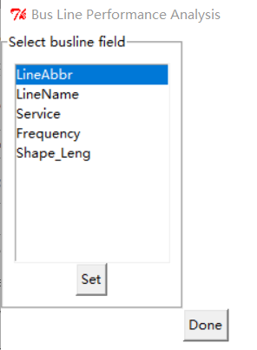

Figure 4. Select bus line id

Finally, click “Set” -> “Done”.

# **Choose GTFS files**

Click buttons “7. Browser”, “8. Browser” and “9. Browser” to choose GTFS routes.txt, stop times.txt and trips.txt.

# **Choose Output folder**

Click button “10. Browser” to choose the output folder. The result files of calculating equality (cal_equality.json and equality_csv.csv) will be generated in the output folder.

# **Calculate the Results**

There are two methods to generate the results. If you want to use Overlap method, just click the “Calculate Overlap” button. If you want to use Centroid method, just click the “Calculate Centroid” button.

After clicking the button, a window will appear to indicate that it may take a long time to calculate, especially for Overlap method. Therefore, do **NOT** click any button until the window shows finished.

# **Calculate Operational Efficiency**

# **Choose Output Folder**

See 3.2.5.

# **Choose DEA Input Excel File**

First, click the “11. Browser” button and choose the bus routes input shape file, e.g. DEA_input_dataset.xlsx.

Then click the “12. Setting” button to choose the field in the shape file which can represent the bus line id, input fields and output fields.

Like the figures below.

1. Select bus line field, the click “Set” below.

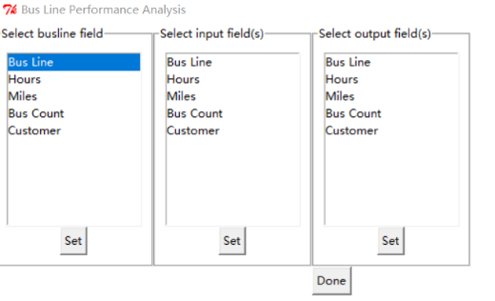

Figure 5. Select bus line id

1. Select input fields, the click “Set” below.

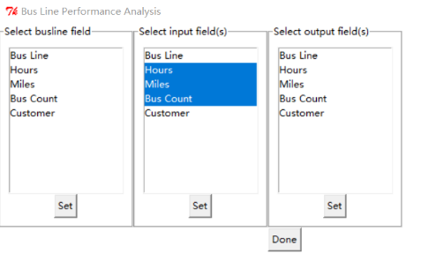

Figure 6. Select input fields

1. Select output fields, the click “Set” below.

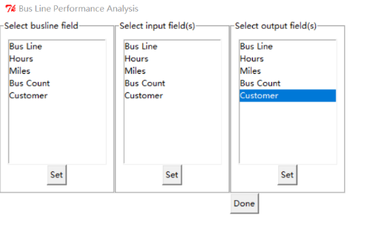

Figure 7. Select output fields

1. Click “Done” button.

# **Calculate the Results**

Click “Calculate Operational Efficiency” button to generate the results. The result files of DEA (cal_dea.json and cal_dea.csv) will be generated in output folder.

# **Optimization**

# **Choose Input Shape Files**

See 3.2.2 and 3.2.3.

# **Choose Output folder**

See 3.2.5.

# **Choose Equality Output JSON file**

Click button “13. Browser” to choose the “cal_equality.json”, which is the result of 3.2.6.

# **Choose Operational Efficiency JSON file**

Click button “14. Browser” to choose the “cal_dea.json”, which is the result of 3.3.3.

# **Choose GLPSOL Binary file**

Click button “15. Browser” to choose the “glpsol.exe”, which is in glpk package, e.g. “winglpk-4.61\glpk-4.61\w64\glpsol.exe”. If your system is 32-bit, please choose “winglpk-4.61\glpk-4.61\w32\glpsol.exe”.

# **Choose Output Rank Folder**

Click button “16. Browser” to choose the output rank folder, which is used to store the results of optimization.

# **Do Optimization**

Click button “Do Optimization” to run optimization.

Then a window below will appear.

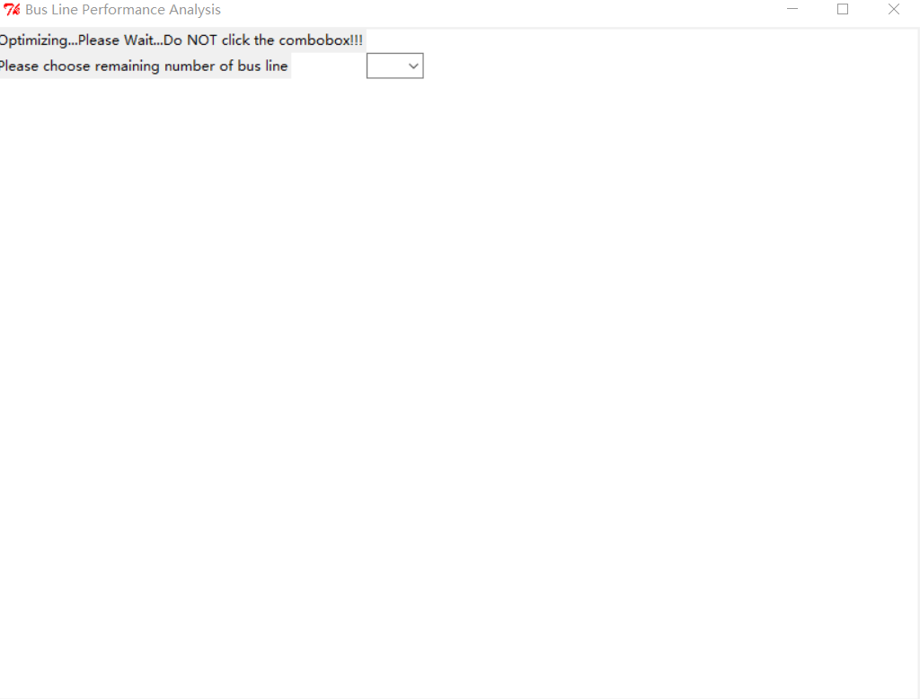

Figure 8. Optimizing

Do NOT click any button or combo box until it finished. If it finished, you can see the window below. Then click the combo box to choose the remaining lines you wish.

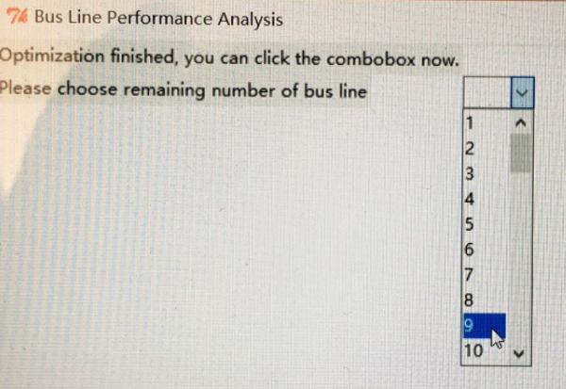

Figure 9. Optimization finished

Then you can see a window below, which is the result of the remaining bus lines. Each red circle is a result due to different operational efficiency score and disadvantage population served.

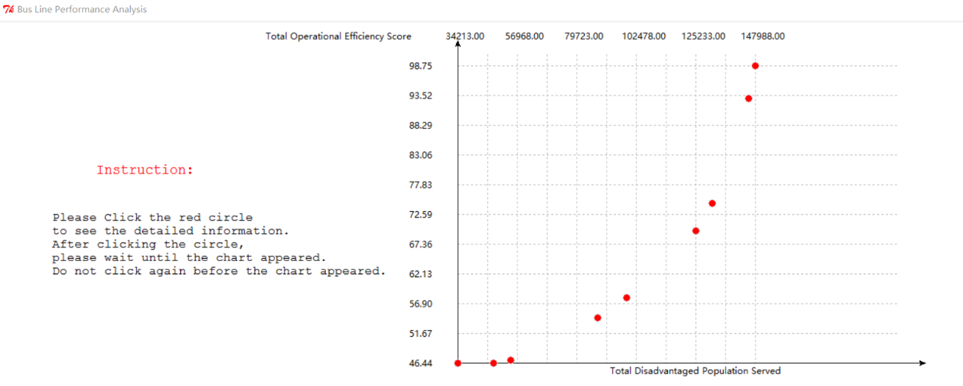

Figure 10. Results of remaining bus lines

In the figure above, you can click any red circle to see the map view according to selected bus lines and block group. But if you have clicked a circle, do NOT click a circle again before the chart of previous clicking appeared.

# **View Results**

If you have done an optimization once, you can just click the “View” button to see the previous results without calculating.

But before click the “View” button, please make sure:

1. You have done an optimization before
2. Fill the item 3 ~ 6 (see 3.2.2 and 3.2.3), item 10 (see 3.2.5), item 13 ~ 14 (see 3.4.3 and 3.4.4) and item 16 (see 3.4.6).